How to stay popular in the WORLD OF Instagram

# Introduction to Instagram

## Why people use Instagram?

There is nothing better than a picture to tell a story. Instagram is a visual sharing platform where it lets its user to make visual contents and share them with the world.

So let me just show some examples

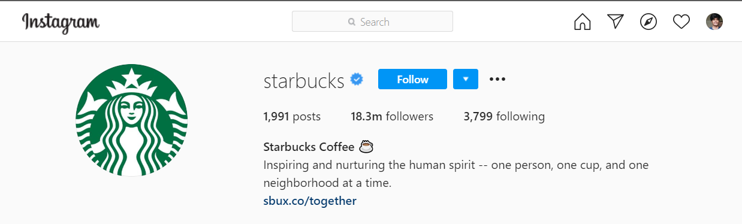

Starbucks are gaining popularity in between teens through Instagram they are promoting their beverages mainly through user generated content and promoting them to purchase more of their product.

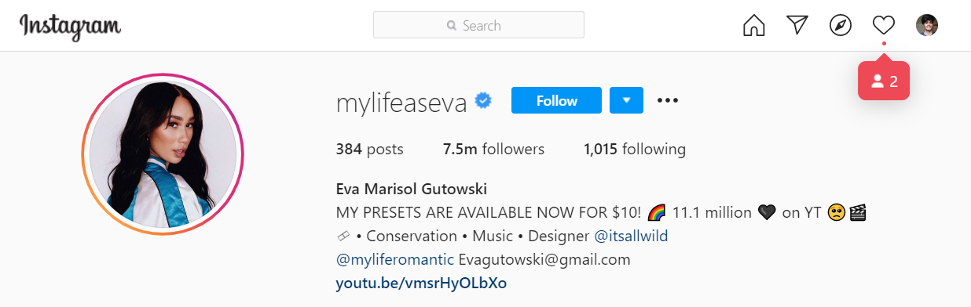

Here you can see eve is promoting her YouTube channel and informing user about her presets.

she is more like a original content creator with her dashing Instagram able life style which she share among her followers.

Similar to Facebook or any other social networking site, everybody who create an Instagram account gets their own profile and feed.

Instagram algorithm in 2020 works by showing users what they wish to see from their previous Instagram engagement.

Once you post a photo or video on Instagram, it will be displayed on your profile. The users who follow you will be able to see your posts in their own feed. Likewise, you will be able to see post from other users who you follow.

since there is so much to know about Instagram and its features I have segmented the entire topic under each sub headings

## Do I need any prerequisite knowledge to understand this guide to Instagram?

This guide is specially built for beginners as well as users who are looking to expand their user base.

This Guide to Instagram will help you uncover every hidden tricks of the platform and help you connect with others in different ways.

# User name / Handle selection

Creating a handle in Instagram is as important as naming your own child. It is the heart of your Instagram account because it is used to discover your profile, your brand and main factor whether a person will follow you.

Let’s see some example here in this entire guide I am using @adidas as an example for business profile and @mylifeaseva as personal account. as you can see the images below.

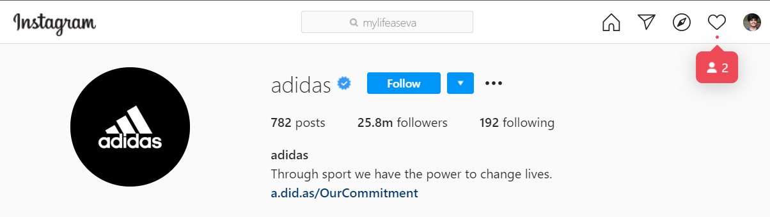

## Some best practices to understand the criteria for the perfect username on Instagram:

* Identify the purpose of your Instagram (personal, business, curation).

That is as you can see in the above image Adidas is a brand and it is mandatory to include the brand name because this is how Adidas fam (family + fan = fam) can find them on Instagram.

And in the 2nd image here the brand is the person itself and they are called influencer becaude they can influence their fam with their post.

* Make it relatable to your targeted audience or in other words user base. For example if you are creating an account for your pet store "friendly paw" @friendly_paw will be a good example (you can use your creativity until it make since).
* Keep it simple, even though there are 30 symbol limit try to keep it less confusing and memorable. @mylifeaseva (my life as eva) is a perfect example for a personal brand account which can be memorized with no effort but @AwwwCuteDogs this is confusing because of number of w in “Awww”.
* Be unique, you maybe be tempted to follow footsteps of an established account for example @Nike.peeter you might get users that follow you based on their loyalty towards Nike. But once your account gets big, Nike has the power to close your account due to trademark infringement. Your aim is note to increase followers it should align with your brand.
* Bonus tip: there are username generator for effort less Instagram handles and they are free to use such as
* www.bestusernamegenerator.com
* www.spinxo.com/Instagram-names

but still I would like you to create your own user name, give some time and take a lot of inspiration from above link from bonus tip.

# Instagram hacks for creating cool bio

Think your Instagram profile and bio as your first impression towards the new followers. you want to let your followers know exactly who you are and what you do by just looking at your profile and bio.

So a well laid out profile is key to leaving a lasting impression!

So I am using the same profiles as above for examples.



We know Adidas is a sport company and we can clearly understand it by just reading the bio even though bio is short and simple.

We know that Instagram have a limited character constrain on bio but we are free to provide link or mention an Instagram ID in the bio. This feature can be used to direct follow to a page that company want them to checkout.

This feature can be used in variety of ways one of is it direction to personal website and other is direction it to a page where multiple link is provided that the company wish its users too checkout.



As you can see in this personal account Eva is promoting her YouTube channel and her products that is launched in her name with appropriate link even her email is given for contacting her for creative collaboration with other brands as she is a influencer with huge follower base.

## Here are some hacks for creating cool Instagram bio that will help you stand out from the crowd:

* Edit your Instagram bio from laptop by clicking "Edit Profile" on your profile. This will open your settings tab where you can write your bio directly with all your line breaks included!!



Checkout the yellow highlight where you can see “Edit profile” option.

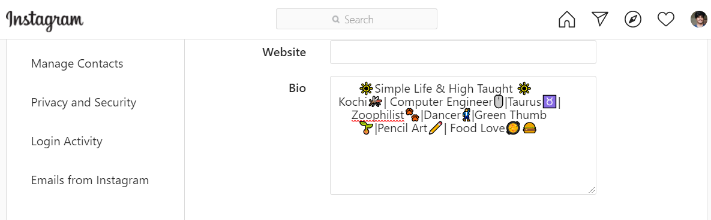

Check out the image above you can easily put line break if you edit in a full desktop version of Instagram.

* Add link to other sites or hashtag in your bio by including a # or @ before a word or account, other users will be able to click on it to discover more! This could be really useful if you’re running branded or campaign

For an example Adidas when launch a product they usually run an #tag (hashtag) campaign which will be shown in their bio so that users don’t miss it.

* Find the right alignment for your bio this might take some trial and error but the result will be an eye catching bio which stands out! (**Important - do not compromise on your brand message to get the alignment right**)
* Add special characters, emoji to your bio. This can be done simply by constructing your bio in word processing program (word, google doc)

What I do for my convenience is that I create my bio in my phone with all the emoji’s and then I send that as a mail to myself then I copy paste that mail to my bio space by appropriate line breaking as you can see in the below screen shot.

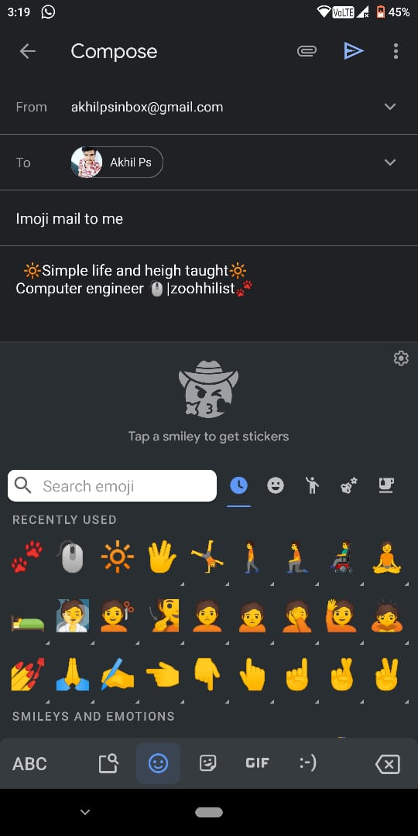

# Personal to business account

If you are planning to use Instagram strategically or if you are a brand looking for business Instagram, you are definitely going to need a business account. Because there are many advantages here.

* You will be considered seriously: Business account show their brand's industry, actress and contact button on the profile which personal accounts do not have.
* Access to analytics: You will be able to measure the performance of your post, follower’s activity and an insight on your audience.
* You can add link to your stories: swipe up link feature get added to your business profile once you cross 10,000 followers
* Advantage of Instagram ad: you must have a business Instagram account attached with Facebook to be a part of this ad campaign. Paid ad can help you achieve your targeted audience quick
* You can tag products in your post: another great feature which is only available for business profile is to turn your post into online shopping.

## Guide to convert your personal profile to business profile

1. Click on the icon as seen on the image. (Make sure your profile is set to Public)

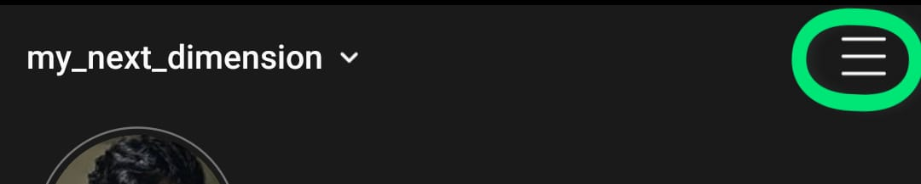

1. Click on the “settings” and then tap on “account” and then “switch to professional account”.

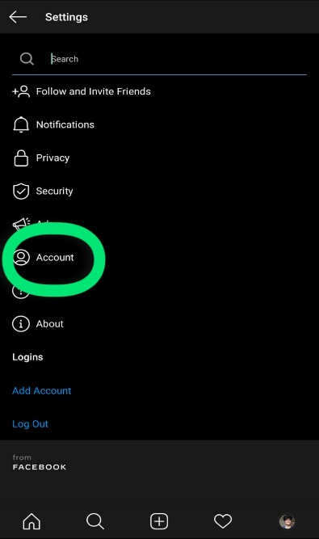 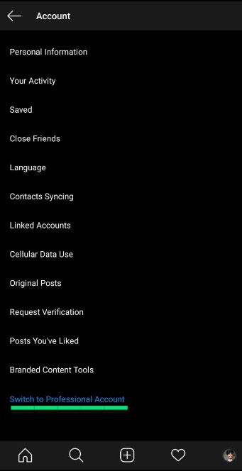

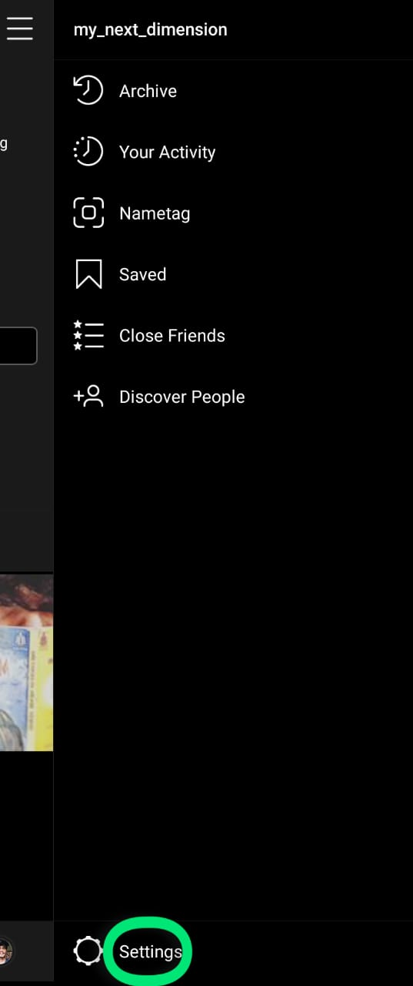

1. Now choose your option creator or business.

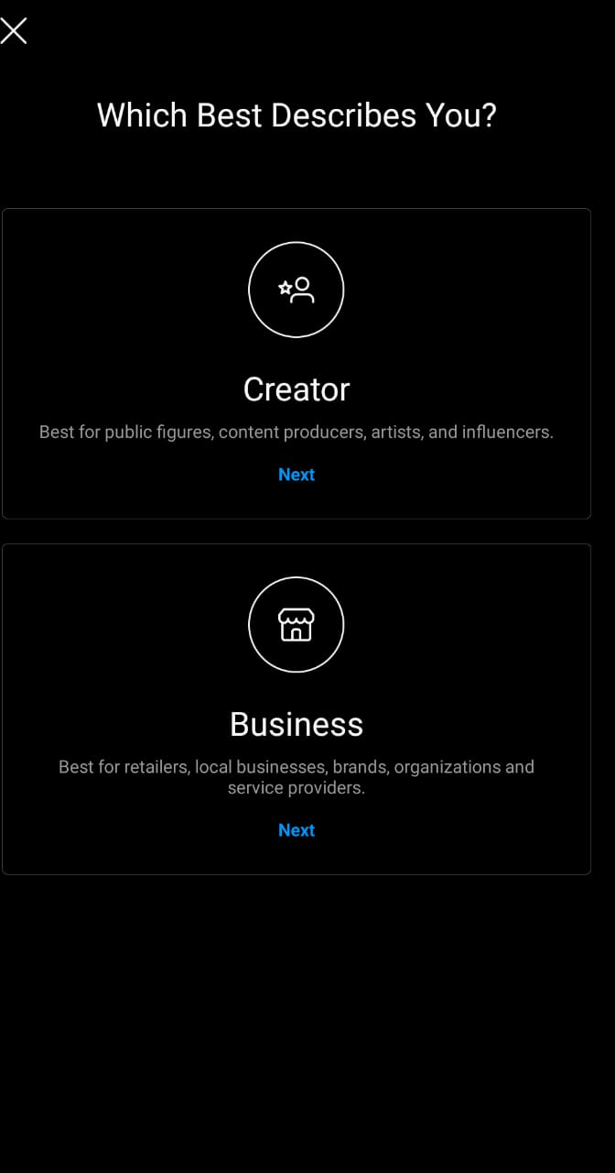

1. Set up your business profile page (fill contact information, link Facebook page and also mention tag for you account below categories are for business account)

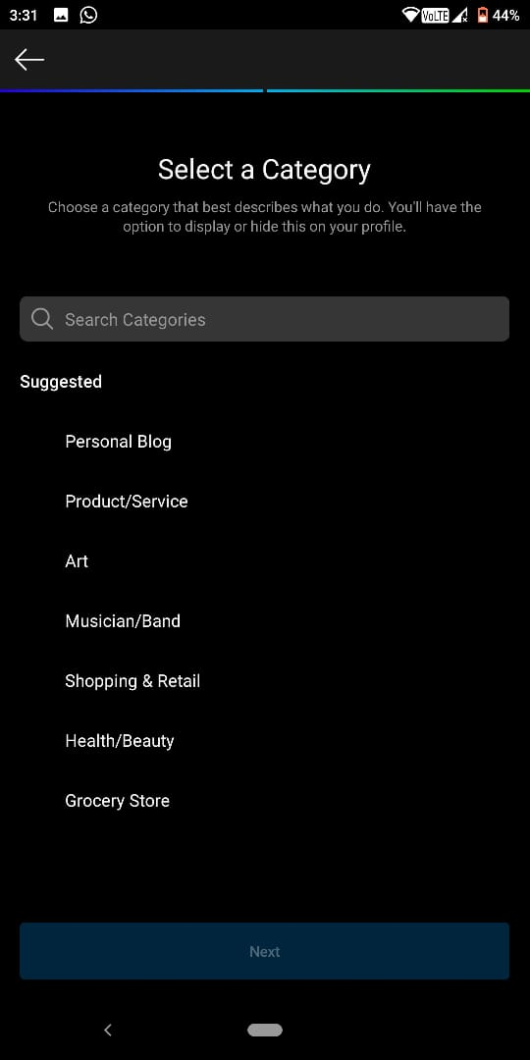

# Instagram profile pic: tips and ideas for brand and influencers

Scrolling through pictures in "discover" sections suddenly your eye get stuck at a beautiful landscape you decide to click on it and once you finish looking at that photograph you decide to check the profile when you look at the profile picture you see blur clueless image.

Not so cool right!!

Looking at that profile picture you must have thought that this must be a work of true outdoor enthusiast who lead an exciting life but that profile picture turns u off.

*This is a good opportunity to read think and change that profile picture*

## Best tips to take perfect profile pic

* Choose a nice outfit for your profile picture it must align with your brand.  If you run a cafeteria, pretend that you are drinking a coffee; if you’re a business professional, put on a tie.
* Choose a nice background for your profile picture it should never distract the user from the main subject
* Take your profile picture in a well-lit place. A good lighting will eliminate those Harsh shadows.
* Try to smile users must have a welcoming feel looking at profile picture.
* Show your face, the picture must be professional your picture of you standing next to a Ferrari or cartoon version of your picture will not do the magic. Professional means clear and up-to-date.

# How to use Instagram stories to build audience?

Basically a story is a self-destruct style of content it is a simple that is in short when a person posts a story the life of the story is just 24 hours

Stories are basically the secondary exclusive seeds that you are giving your audience

When you post a story on Instagram it creates a purple round around it which creates an urgency on followers to click on it.

## Types of stories to try

* **Tutorial / how to**

Stories are a best means to show a step-by-step process because it is shown in a sequential order why not utilise it for our benefit

For example, I would like to show how Samsung uses their story to educate people and encourage them to share their creation using their hashtag for the opportunity to be featured in their feed. (#withGalaxy is one such campaign)

* **Share user generated content**

Many of the brands of their use their stories to showcase their followers. Encourage them to purchase more of their goods and share it among their social media. By featuring user-generated content as a field in the story can build loyalty among followers/customer.

One mail example is converse they have dedicated their story feed for such user generated content. They tag their customers with the photo that they shared on Instagram.

* **Behind the scenes**

This is a wonderful and cool idea that the millennials use nowadays because this need very less effort to make a feed on story and can build loyalty with their followers making them feel more exclusive.

* **Time sensitive offer, details and promotions**

We know stories only last for 24 hours you can utilise that feature for your exclusive offers deals and promotions which has a time constraint.

Also showing such feed on stories can create an urgency on followers to take action immediately before the story vanishes.

* **Special announcements**

Here the main objective is to make your followers feel exclusive and always keep them engaged. even you can ask occasionally in your normal feed as a reminder to check your stories it is not spammy .

For example, if you are launching a new product under your organisation you can tease audience through these stories.

* **Ask me anything**

this is basically a Q&A session that is being conducted through your stories this is mainly done to engage with the audience answer their questions.

# Discover people

When it comes to follow account on Instagram it’s one thing to decide who to follow when you use Instagram for personal use only. But situation is different when you use it for business purposes, I know it’s confusing as to who you should follow on Instagram.

In reality it’s about your taste or in other words interest. in future what you wish to see may evolve and similarly what they choose to share will also evolve people change, so will you.

## Here are some Guidelines to consider (But again it’s up to you that what you want to see):

* **Follow those accounts that interest you:** This is the biggest and important tip. Follow those Instagram accounts who’s feeds interest you. This is your account and you are the only one using it. If you are scrolling through images, then well it must be appealing to your eye
* **Follow good example:** I highly recommend you to find those accounts and brands similar to your industry and in other industries who uses Instagram like a charm. follow them. Watch what they do. See how they engage with their users. See what works and what doesn’t basically learn from them.
* **Follow your customers sometime:** If you have dedicated, raving fans in your customers, it’s worth following them back. Engaging with them and showing them you care about them too will go leaps and bounds in the right direction.
* Bonus tip: Never follow back everyone!!

# Posting strategy

"How often I should post on Instagram?" I bet you've asked yourself that question a million times but have never been able to figure out the answer. It all depend on what your audience need more than what you think they need. Still there are some tips to keep you safe on Instagram posting strategy.

* **Consistency Over Frequency**: Your perfect posting frequency will rely on you or your business’ goals and the amount of time you can dedicate to your Instagram quality content creation.
* **Posting More Often During Special Events**: there will be times when you will have to bump up your posting frequency! For example, the popular brands post nearly 10 times in one day when they are launching their new products.
* **Quality Over Quantity:** While posting frequently in Instagram will help you gain the reach by likelihood that your content will be seen. If your quality of the content is not up to the point, then the engagement will decline

# Content Creation

When using Instagram to grow your brand or business, it’s essential to build up a user base that is engaged and loyal to your brand. How to increase followers in Instagram? This is the question that pop up well we are not targeting any people we need loyal users genuinely interested in our content.

There are 2 options Out sourced or In-House content creation

* Instagram is about picture or visual contents so there are some key details to notice when you are creating you own content.
  + **A Decent Camera:** You must have a decent quality camera to capture your subject with best image quality (quality of you photo matters because as this photos travel through editing software its quality decreases)
  + **Good Lighting:** try to take pictures in a well-lit place because those extra light can really eliminate unwanted harsh shadows.
  + **Editing:** Lets accept the fact that there is no perfect photos! Even if u manage to take a great picture running through an editing software for some minor detailing can make a big difference.
  + **Framing:** there are some Common Aspect Ratios for Instagram and that is 1.91:1 to 4:5. This is very important because your subject need to be in the centre of the picture and if the frame size is not right the image may look distorted which is visually not appealing or clickable.

**secret tips to increase followers in Instagram fast!!**

* **Reposting and crediting ownership**: this is a good way to engage the followers and have a free content (easy right but don’t do this for your every post)
* **User generate content to create strong customer base**: that is, you can start hashtag captain where your users can participate which is beneficially to both the parties.

for example, when Nike launces any product they also put a hashtag for users to participate so that if they purchase that product for them self they can create content with it and show it off in the hashtag campaign.

* **Hashtags** (use trending and relevant): Hashtags changes the game it is one of the key element which brings new users into your account daily if you ask me.

I know sometimes it’s overwhelming to see so much hashtags under a post but the easy way as a beginner is to use those free tools that help you create hashtags but always remember to stick to your content because we need a loyal and active user base.

You can also see your competitor post and learn how they use their hashtags at initial stages of your Instagram post.

# Schedule content (with tools)

If you are like most of us who don’t have time to regularly create post daily, there is an option to make you post in advance maybe for a week.

so now you are done with your one week feeds next you must be thinking it would have been easy if someone could just upload it at a specific date and time automatically without you manually doing it funny right!!

But this is actually possible there are apps and services that does this for you all you have to do is to link you Instagram account to these services and you can sit back.

## Popular tools to schedule Instagram posts

* https://buffer.com
* https://facebook.com/creatorstudio

# Shopping tags

Instagram is shoppable now. why should I care? this is a great question. until recent times the only way to direct your user to external URL was just with your stories and bio

Now luckily with shoppable Instagram you can now create a “one-tap” shop, allowing people to buy your products with a single touch of a finger. And to top it with cherry you don’t even need to be a big account to be able to do that. In fact, even if you’re a small shop around a corner, it’s still possible to enable the shoppable account.

## So…

* Shorten the journey of buyers.
* Drive sales directly from Instagram.
* Make your profile a small online shop.

# Influencer Marketing

People who have built a large following base with engagements on Instagram are known as ‘influencers’, due to the fact that their followers adore them and respect their opinions. They may have acquired a loyal following due to their post, lifestyle, their job or hobby, the clothes they wear or the way they tell stories.

## Why Influencer Marketing Works?

Influencer marketing it feels far more genuine than traditional advertising because, they are building relationships with influencers and they are sell your product for you.

This works like charm because the user base of an Instagram influencer is genuine, as they share many aspects of their lives with their followers this lead us to feel like we know them completely, so when an influencer recommends something we take that as advice from our friend.

Important element of a good influencer is that they are responsible with their choices of partnership, truly taking into their followers’ interests.

There are bots that will comment on posts of users in order to attain target demographic or using certain hashtags in order get more followers and to increase brand awareness.

## How to Work with Influencers On Instagram?

If you finally decide to go with an influencer, then the first most thing is to set a budget this is going to be expensive trust me! And influencer charging for each post and their stories this is going to be a long game.

Spend some time in researching about the influencer and their Instagram account. Importantly, treat your working relationships as partnerships. Always Remember they know what their followers engage with best, and trust them in the content creation process!

# Why Instagram Ads

This is a feature available to the business account users only, you are basically paying Instagram to promote your post. Throwing some money behind your post can really increase exposure of your brand.

Does this work for me? This is the question that come next, so my answers for this is more like it depends on you targeted audience. Instagram is all about selfies and colourful teen lifestyles and if your brand is targeting such audience this is a wonderful option to explore.

Of course Similar to many other social advertising platforms, Instagram also gives you the verity of control to target specific genders, age ranges, locations, interests, and more.

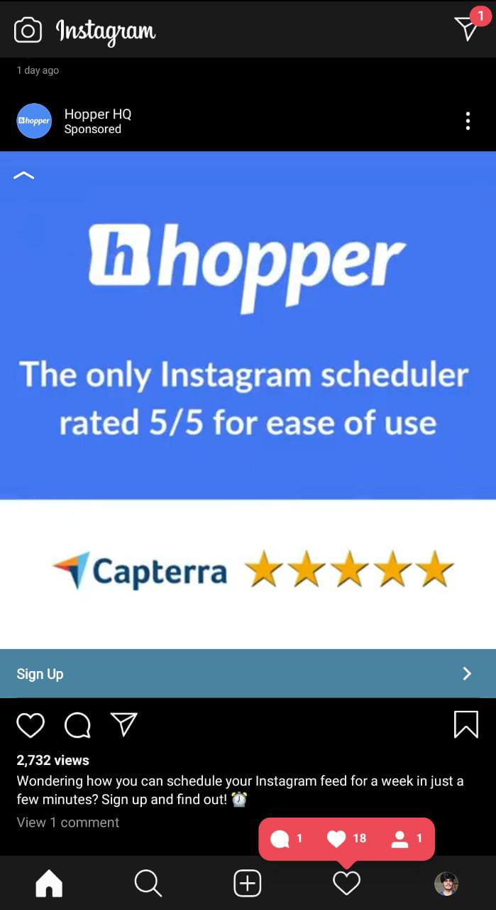

As you can see above in the image once your post is given for promoting this is how it is appeared on the mobile app of Instagram.

# CONCLUSION: SOme bonus tips to be an insta star

* If you are too much pushy then your followers will drop like flies. But teaser posts of your product are a simple way to talk about your product and increase excitement without looking like you’re trying too hard.
* Use Instagram Stories, if you want to generate leads, Instagram Stories are the best source they tend to be in profile for 24 hr and you can even save those for later use.
* Be active on comment sections of influencer pages, take time to write your comments and make your comments interactive.